**1 – Instalando o create-react-app**

yarn global add create-react-app

**2- gerando um novo projeto**

create-react-app gitcompare

2- **Instalando depedencias eslint**

yarn add eslint-config-airbnb eslint-plugin-import eslint-plugin-jsx-a11y eslint-plugin-react -D

3 – Configurando o ESLINT:

* Crie esse arquivo na raiz do projeto

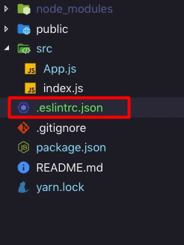

* Adicione essas configurações

{

"env": {

"browser": true,

"jest": true,

"es6": true

},

"extends": ["react-app", "airbnb"],

"plugins": ["import", "jsx-a11y", "react"],

"rules": {

"react/jsx-filename-extension": [

"error",

{ "extensions": [".js", ".jsx"] }

],

"import/prefer-default-export": "off",

"react/jsx-one-expression-per-line": "off"

}

}

4- Criando o editor config:

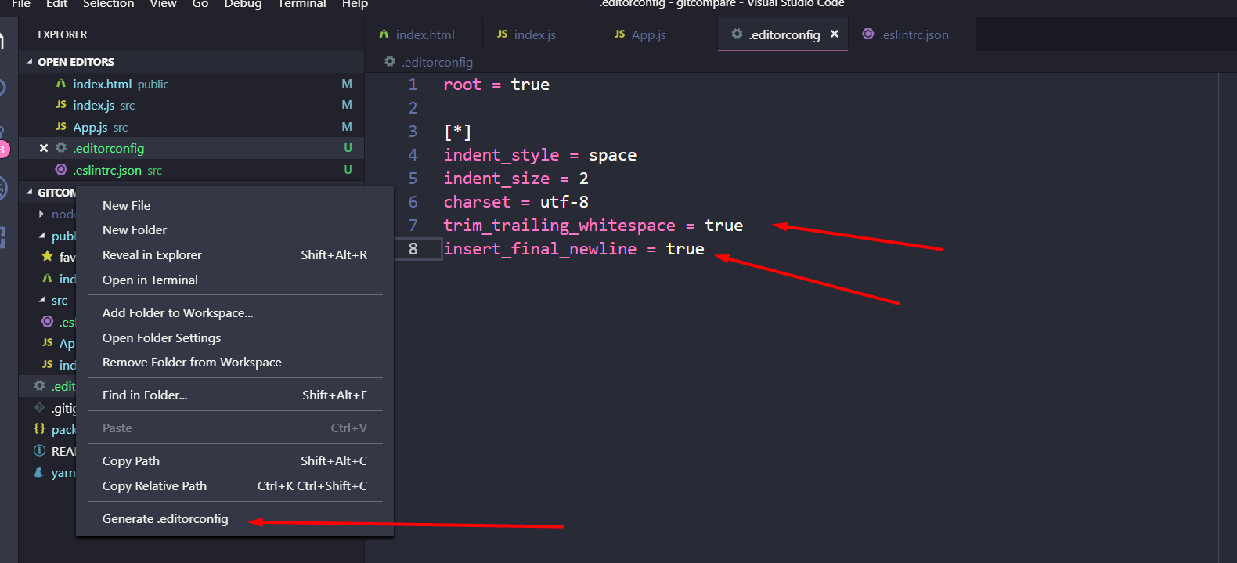

5 – Estrutura redux

Yarn add redux react-redux

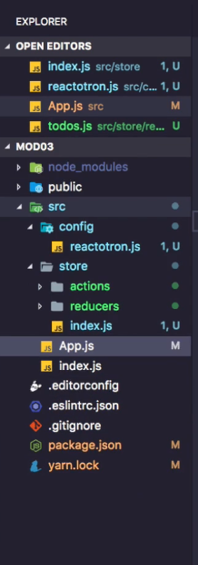

Criando o Store index.js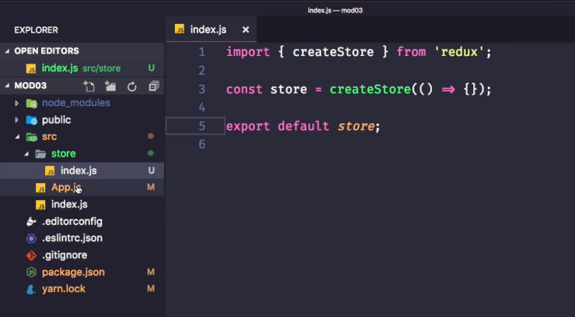

6- Criar reducer

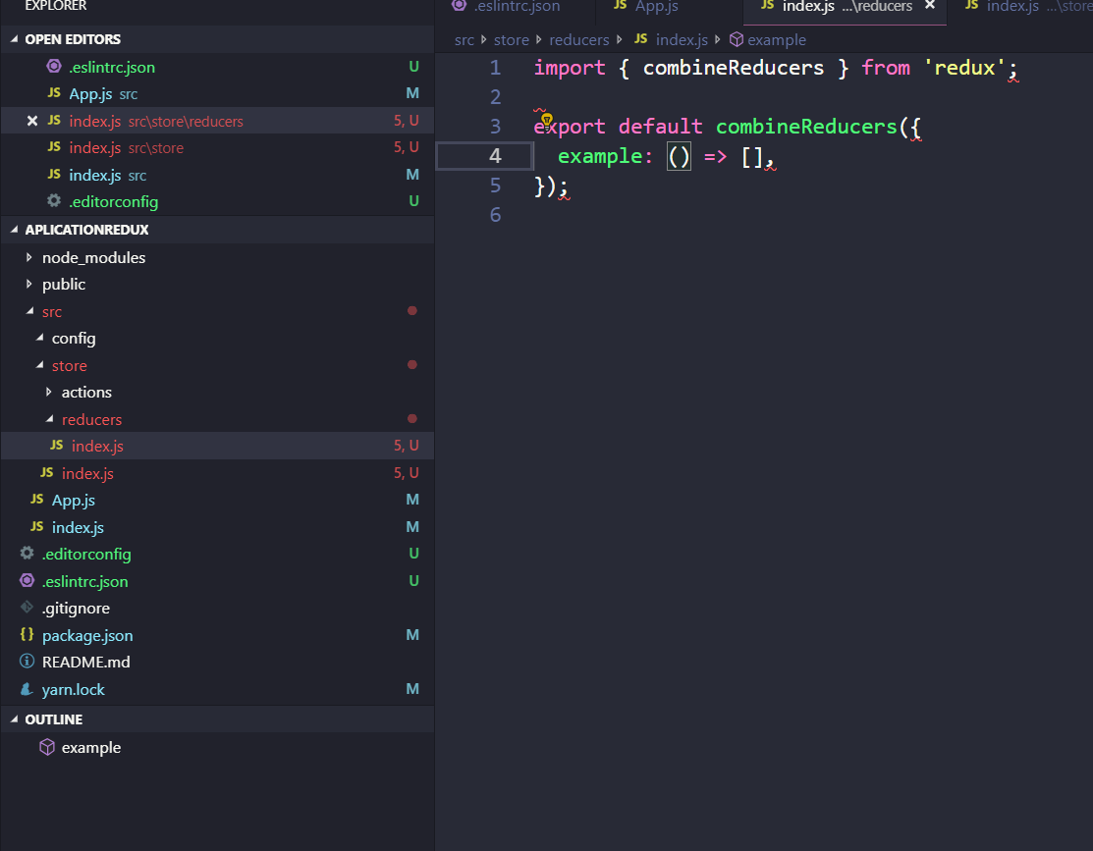

7 – Instalar React router dom

Yarn add react-router-dom

* Criar pastas pages e routes

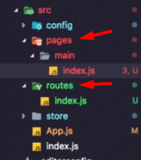

Criando index.js de rotas

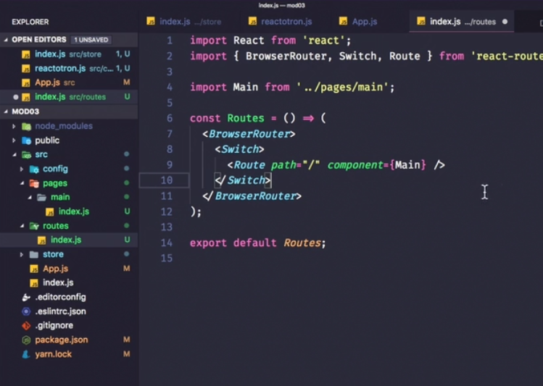

Configurando Cors no backend

Yarn add cors

